Consider the following Java code fragment. Which of the following statement is true?
Line No | Code Statement
1 | public class While
2 | {
3 | public void loop()
4 | {
5 | int x = 0;
6 | while (1)
7 | {
8 | System.out.println(“x plus one is” + (x + 1));
9 | }
10 | }
11 | }
Solution:
There is syntax error in line no. 6 EXPLANATION:
Option 1: FALSE
“While” is not a keyword, hence it is valid to use it as a class name.
Option 2: FALSE
Since Option 1 is false, so this option is by default false.
Option 3: FALSE
Any string operation can contain an equation type of expression.
So, this is not any kind of syntax error.
Option 4: TRUE
Java uses condition as Boolean expressions like:
while(true) or while(false)
Hence, while(1) is the wrong syntax for java.
while(1) will give compiler time error as it treats as type mismatch to convert from integer to boolean value.
Hence, the correct answer is “option 4”.
What is the output of the following program?

Class Test
{
public static void main (String [] args)
{
int x = 0;
int y = 0
for (int z = 0; z < 5; z++)
{
if((++x >2)||(++y > 2))
{
x++;
}
}
System.out.printIn (x+ "" + y);
}
}
Before solving the questions, if we think why they asked this particular question then probability of getting correct answer increased. For example this question is an example of Short-Circuit Evaluation.
Here is the Answer:
𝑧=0 : 𝑥=1 and 𝑦=1, Because 𝑥++; will not be executed because condition is false
𝑧=1 : 𝑥=2 and 𝑦=2, Because 𝑥++; will not be executed because condition is false
𝑧=2 : 𝑥=4 and 𝑦=2, Here 𝑥++; will be executed, but ++𝑦 will not be executed due to short circuit evaluation
𝑧=3 : 𝑥=6 and 𝑦=2, Here 𝑥++; will be executed, but ++𝑦 will not be executed due to short circuit evaluation
𝑧=4 : 𝑥=8 and 𝑦=2, Here 𝑥++; will be executed, but ++𝑦 will not be executed due to short circuit evaluation
Hence at the end, It will print 8 2.

What will be the output of the following Java program?

class test

{public static void main (String args [ ])

{

System.out.println(20 + 30 + "Java");

System.out.println("Java" + 20 + 30);

}

}
output
50Java
Java2030

Match List I with List II
List I |  | List II
(Programming Term) |  | (Meaning)
A. | JNDI | I. | Runtime support for running Java programs
B. | RMI | II. | The API in support of naming and directory services
C. | JDK | III. | The methods provided by the Java development kit and runtime support for calling remote methods
D. | JRE | IV. | The compiler and class libraries to develop Java applications
- A ‐ II , B ‐ III, C ‐ IV, D ‐ I
- A ‐ II, B ‐ IV, C ‐ III, D ‐ I
- A ‐ I, B ‐ III, C ‐ IV, D ‐ II
- A ‐ III, B ‐ II, C ‐ IV, D ‐ I

Answer
Option 1 : A ‐ II , B ‐ III, C ‐ IV, D ‐ I

Which of the following methods will create a string in Java?
I: String S = "Hello Java”;
II: String S2 = new String (“Hello Java");
- Only I
- Only II
- Both I and II
- Neither I nor II

Answer
Option 3 : Both I and II
The correct answer is option 3.
Concept:
A string is an object in Java that indicates a collection of characters or char values. A Java string object is created using the java.lang.String class.
A String object can be created in one of two ways:
By string literal:
Java String literal is created by using double-quotes.
Example:
String s=“Welcome”;
By new keyword:
Java String is created by using the keyword “new”.
Example:
String s=new String(“Welcome”);
Hence the correct answer is Both I and II.

What is the output of the following java code?
int m = 1000;
int k = 3000;
while (+ + m < – – k);
System.out.println(m);
- 2000
- Error
- 1000
- 4000

Answer
Option 1 : 2000
Concept:
Java is an object-oriented programming language that produces software for multiple platforms. In the bottom-up approach first designing, beginning from the base level to the abstract level is done. e.g.-In c++/java starts designing from class from the basic level of the programming features and then goes to the main part of the program.
Analysis:
Here m stores 1000 and k stores 3000.
While loop condition is true until (++m < – –k) and it is not executing any statements because of the semi-colon(;).
Every time comparing the condition (++m < – –k) m and k values will pre-increment and pre-decrement respectively.
Ex:
1001 < 2999 true do nothing.
1002 < 2998 true do nothing.
1003 < 2997 true do nothing
......
1998<2002 true do nothing.
1999<2001 true do nothing.
2000<2000 false come out from while loop and prints the value of m.
And prints the m=2000,
Hence the correct answer is 2000.
Note:
while (+ + m < – –k);
In this statement m and k values will be, the amount which increased is equal to the amount decreased. So the condition is false when it is mean between the two numbers.
if m=500 and k=3000
the loop condition false when = 𝑚+(𝑘−𝑚)2
m=500+1250.

For this homework assignment, you will need to submit 4 .java files: Book.java, TestBook.java, MyMethods.java, and TestMethods.java. Do not name them hw#_FirstnameLastname.java.
DEFINING CLASSES
- Write a class called Book that contains instance data that represents the book’s title, title, as a String and number of pages, pages, as an integer. In addition, the class should have the following methods:
  - A default constructor, which initializes title to “Java Programming” and pages to 200
  - A getter for each instance data
  - A setter for each instance data
  - A toString() method that returns a one-line description of the book including title and number of pages.
- Write an application TestBook that instantiates two Book objects and updates the titles and pages with data from the user. The program will display the information about each object (Hint: toString() method) as well as the average number of pages.
WRITING METHODS
- Write a class MyMethods containing the following 2 methods:
  - a method named volume() that accepts 3 double parameters named width, length, and height. The method returns the volume of the rectangular box it represents.
For example, if parameter values are 2, 3, 4, the method returns 24.0
  - a method named avgFaceValues that takes 2 Die objects as parameters (Use the Die class developed in class). The method returns the average face value of the two die objects. For example, if the first parameter is a Die object with face value 3 and second parameter a Die object with face value 4, the method should return 3.5.
- Write an application, TestMethods, that tests(invokes) the methods in problem 1. The program should instantiate an instance (object) of the class MyMethods and invoke the methods with made up parameter data. The application should have at least one invocation of each method.
- Match List (I) with List (II)
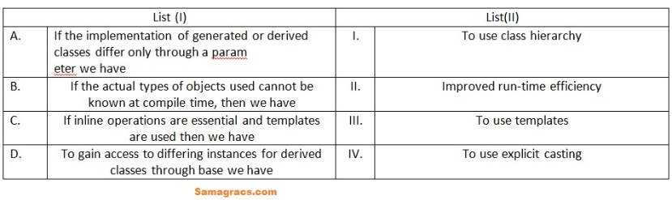
Choose the correct answer from the options given below:

i ➥ A-(I), B-(II), C-(IV), D-(III)
ii ➥ A-(III), B-(I), C-(II), D-(IV)
iii ➥ A-(I), B-(III), C-(II), D-(IV)
iv ➥ A-(II), B-(I), C-(III), D-(IV)

Best Explanation:
Answer: (ii)

Match List (I) with List (II) :
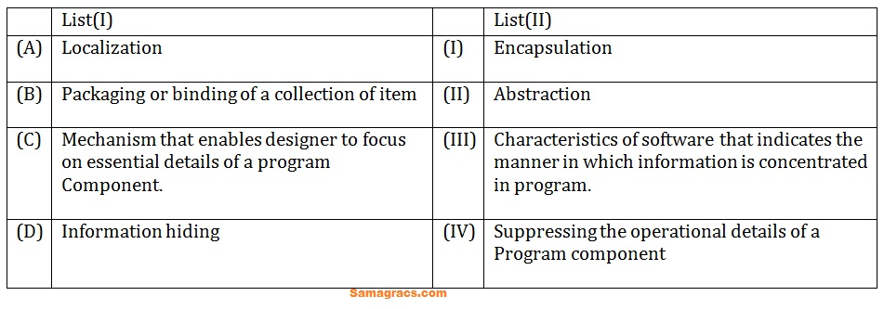
Choose the correct answer from the options given below:

i ➥ (A)-(I),(B)-(II),(C)-(III),(D)-(IV)
ii ➥ (A)-(II),(B)-(I),(C)-(III),(D)-(IV)
iii ➥ (A)-(III),(B)-(I),(C)-(II),(D)-(IV)
iv ➥ (A)-(III),(B)-(I),(C)-(IV),(D)-(II)

Best Explanation:
Answer: (iii)
Explanation: Upload Soon
Q.34➡ |
Match the following:
Set-I
(a) Garbage collection in
(b) Nameless object
(c) Template support
(d) A forward reference
(e) Derived class inherits from base class
Set-II
1- Java
2- generic programming
3- defines a class
4- member function
5- within a statement
Codes :
(a) (b) (c) (d) (e)

i ➥ 1 5 4 2 3
ii ➥ 1 5 2 3 4
iii ➥ 5 1 2 3 4
iv ➥ 5 4 3 1 2

Show Answer With Best Explanation
Answer: I (Marks to all )
Explanation: Upload Soon
Q.48➡ |
Match the following interfaces of Java. Servlet package :
List – I
a. Servlet Config
b. Servlet Context
c. Servlet Request
d. Servlet Response
List – II
i. Enables Servlets to log events
ii. Read data from a client
iii. Write data to a client
iv. To get initialization parameters
Codes :
a b c d

i ➥ ii iv ii i
ii ➥ iii ii iv i
iii ➥ ii iii iv i
iv ➥ iv i ii iii

Show Answer With Best Explanation
Answer: IV
Explanation: Upload Soon
Q.56➡ |
Match the following with reference to object oriented
modelling :
List – I List – II
(a) Polymorphism (i) Picking both operator and attributes with operations appropriate to model an object
(b) Inheritance (ii) Hiding implementation details of methods from users of objects
(c) Encapsulation (iii) Using similar operations to do similar things
(d) Abstraction (iv) Create new classes from existing class
Codes :
(a) (b) (c) (d)

i ➥ iv) (iii) (i) (ii)
ii ➥ (iii) (iv) (i) (ii)
iii ➥ (iii) (i) (ii) (iv)
iv ➥ iv) (iii) (ii) (i)

Show Answer With Best Explanation
Answer: II
Explanation: Upload Soon
Q.66➡ |
Consider the following JAVA program:
public class First
{
public static int CBSE(int x)
{
if (x < 100) x = CBSE (x +10);
return (x – 1);
}
public static void main(String[] args)
{
System.out.print(First.CBSE(60));
}
}
What does this program print?

i ➥ 59
ii ➥ 95
iii ➥ 69
iv ➥ 99

Show Answer With Best Explanation
Answer: IV
Explanation: Upload Soon
What is the output of the following JAVA program? (June)
- Public class Good {
- Private int m;
- Public Good (int m) {this∙m=m;}
- Public Boolean equals (Good n) {return n∙m==m;}
- Public static void main (string args (D {
- Good m1=new Good (22);
- Good m2=new Good (22);
- Object s1=new Good (22);
- Object s2=new Good (22);
- System∙out∙println)m1∙equals(m2)); System∙out∙println)s1∙equals(s2));
- System∙out∙println)m1∙equals(s2));
- System∙out∙println)s1∙equals(m2));
- }
- }

(A)
True, True, False, False
(B)
True, False, True, False
(C)
True, True, False, True
(D)
True, False, False, False
(E)
None o the above.
Answer (E)
Explanation :
Note: Question is wrong. First change boolean to int data type then there is a possibility of option 4 is correct. So marks will be added to all students. GeeksforGeeks code link: https://ide.geeksforgeeks.org/tWbTXjT2VA Output: true false false false

Consider the following recursive function F() in Java that takes an integer value and returns a string value :

public static String F(int N) {

if ( N <= 0) return "-";

return F(N - 3) + N + F(N - 2) + N;

}

The value of F(5) is :
- -2-25-3-135
- -2-25-1-3-135
- -1-145-2-245
- -2-25-3-1-135

Answer
Option 4 : -2-25-3-1-135
The correct answer is option 4.
Concept:
The given java program that takes an integer value and returns a string value :
public static String F(int N)
{
if ( N <= 0) return "-";
return F(N - 3) + N + F(N - 2) + N;
}
The value of F(5) is :
it calls a return statement sub-functions F(2) + 5 + F(3) + 5;
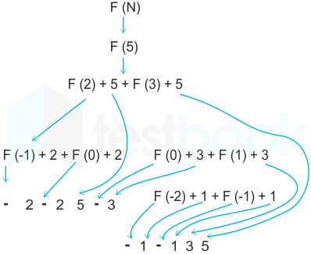
Hence the correct answer is -2-25-3-1-135.

